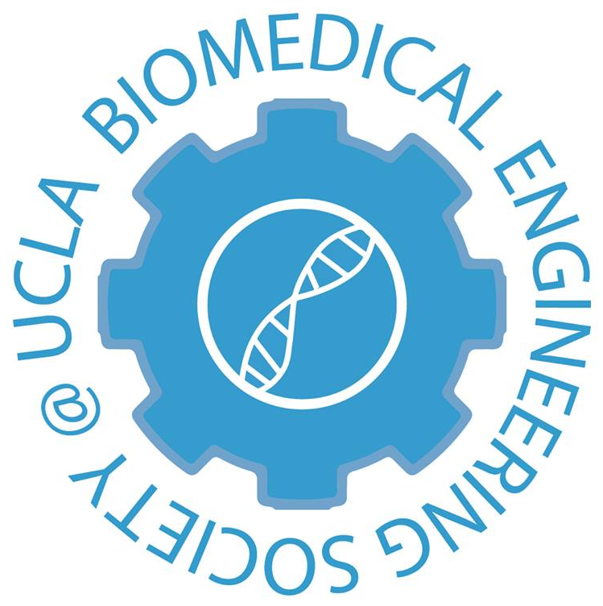
Committee ’17-’18 Application
2017-2018

Please complete the information below, and after reading the responsibilities outlined at the end of this application, select which committee you are interested in applying for. Do not mark a committee you are not interested in applying for.

This application is due by 11:59 PM on Friday, October 13, 2017. Please submit applications by email with the subject “2017 Committee App – Name” to bmesucla@gmail.com . Late applications will not be considered.

If you have any questions, please feel free to contact Eva (evachen96@gmail.com), Derek (derekftw@ucla.edu), or Mandy (hung.mandy.15@gmail.com).
Note: There is no minimum or maximum length, but keeping responses succinct and to-the-point is greatly appreciated.
Full Name
Year
Major
Email
Cell Phone

I would like to apply for the following committee (mark one only):

Publicity & Social Events
Industry & Corporate Outreach
Community Outreach

- Why are you interested in the committee that you have selected?
Click here to enter text.
- What skills or ideas do you believe you can contribute to the committee that you have selected?
Click here to enter text.

- List any previous leadership, professional, or event planning experiences you may have.
Click here to enter text.

- How have you previously been involved in BMES? If you are a new member to BMES, why have you elected to dedicate your time and effort to this organization?
Click here to enter text.
- What other time commitments do you expect to have in the coming school year? Briefly explain your role and time spent in each.
Click here to enter text.

UCLA BMES Committee Program
As a whole, the UCLA Biomedical Engineering Society Board is expected to work to preserve the continued excellence of the chapter and to strive to further improve what BMES offers to its members, the Bioengineering Department, and UCLA Engineering as a whole. To that end, every member of the board is expected to attend, participate, and help prepare for each event that BMES puts on, no matter their individually assigned roles.

Committee members at the start of their term will be assigned to work with specific board officers to help with events, but may also be asked to assist in other tasks in their respective committees. These assignments will be determined based on interest expressed by the applicants in their application and interview. Descriptions of the responsibilities of each relevant board position are listed below, as well as the general expectations of each committee.

During Winter Quarter, committee members will have the opportunity to rotate within or between committees to experience working in a different division of BMES Board. This rotation is optional and based on the levels of interest expressed by committee members. At this time, each committee will also be given an independent project to work on, separate from their assigned duties, to develop leadership and organizational skills.

In Spring Quarter, our Annual Beach Day will be planned by all committee members. General Board applications will also be released at the beginning of Spring Quarter, and committee members will then have the opportunity to apply to become a general board member.

Community Outreach & Project Planning Committee: Members of this committee will be assisting Community Outreach chairs with all volunteer and outreach events, including our Bioengineering Big Buddies (B3) program. Responsibilities will mainly consist of helping to think of lesson plans to teach middle school students basic bioengineering concepts and coordinating all outreach events.

Industry & Corporate Outreach Committee: Members of this committee will be assisting in external club duties. Responsibilities include helping out Industry chairs contact representatives in the biotech industry as well as helping organize Industry Info-sessions. They will also assist the Corporate Outreach chair by contacting potential vendors for our largest event of the year, the Fisher Science Vendor Exposition, while also helping with the logistics during the day of the event.

Publicity & Social Events Committee: Members of this committee will be working on the internal affairs of BMES. Responsibilities include helping Publicity chairs with advertising by printing and posting flyers, making classroom announcements, managing the BMES social media accounts, and other means of publicity for all BMES events. In addition, they will also be needed to assist with game planning and organizing BMES social events with our Social chairs, including larger events, such as Fall BBQ and Holiday Party.

General Board: Roles & Responsibilities

Community Outreach Chair: The Community Outreach Chairs organize all events that involve the participation of the chapter in community service and volunteer activities. This primarily involves organizing, running, and expanding the Bioengineering Big Buddies (B³) educational outreach program. Other outreach programs have in the past included working with local food banks, collaborating with student community outreach organizations, bringing school kids to UCLA for a “Science Day”, and organizing BMES’s participation in events such as Relay for Life and the Heart Walk. The Community Outreach Chairs will also direct Community Outreach Committee in organizing these programs.

Corporate Outreach Chair: The Corporate Outreach Chair is responsible for planning and executing the Annual UCLA BMES Science Vendor Exposition. The Corporate Outreach Chair will coordinate with the host vendor or company to contact potential vendors and organize logistics. The Corporate Outreach Chair is also responsible for working with and directing Industry Committee members to complete necessary tasks for the successful execution of Science Vendor Expo.

Industry Chair: The Industry Chairs are responsible for professional events and for corresponding with industry professionals to schedule company infosessions, company site visits, speakers at the chapter’s general meetings, and resume compilations for internship/job openings. Other major responsibilities include organizing and executing the Biotechnology and Pharmaceutical Meet and Greet, a joint career event hosted with AIChE and ISPE, as well as conducting professional development events. The Industry Chairs are also responsible for working with and directing Industry Committee members to further the success of these endeavors.

Publicity Chair: The Publicity Chairs are responsible for publicizing all events by creating fliers, creating graphics for Facebook events, making classroom announcements, drafting publicity releases for blast emails and the BMES website, helping to advertise for the Bioengineering Capstone Symposium, and for running the BMES Snapchat and Instagram accounts. Depending on the event, the Publicity Chair will also explore other means of advertising and publicity. Additionally, the Publicity Chairs are responsible for maintaining the Boelter Board and the BMES sandwich board. The Publicity Chairs will organize Social and Publicity committee members and other board members as needed to assist with publicity efforts, particularly for the Science Vendor Expo.

Social Chair: The Social Chairs are responsible for organizing all social events within BMES and with other student organizations. Other responsibilities include organizing and planning social outings within BMES board and planning board retreats. The Social Chair will work closely with the Internal Vice President and the Events Committee members to plan and execute large social events. Other responsibilities include creating, managing, and participating on IM sports teams.

